Giving name to Test plan as selenium samplier Test plan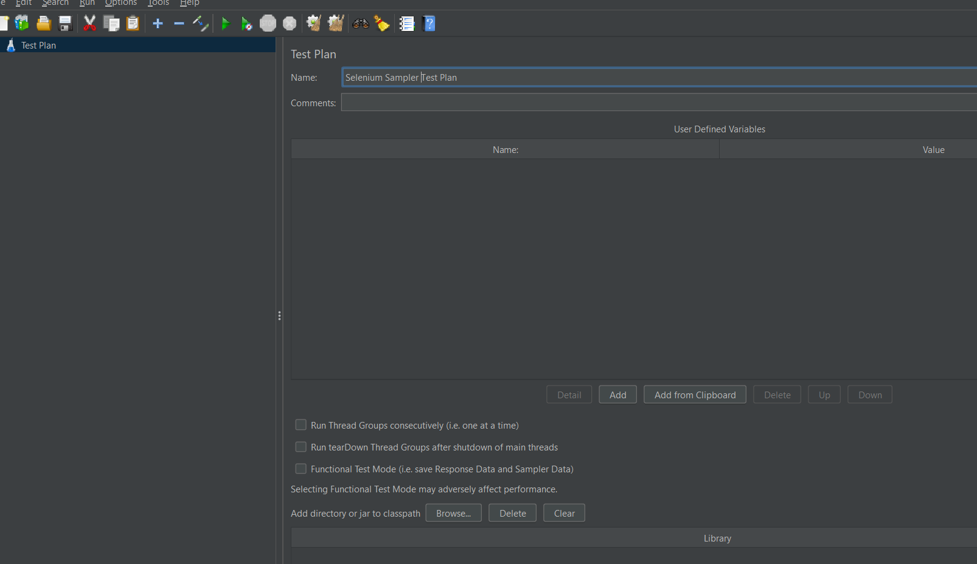

Right click on the test plan and click on the add and click on thread and add thread group.

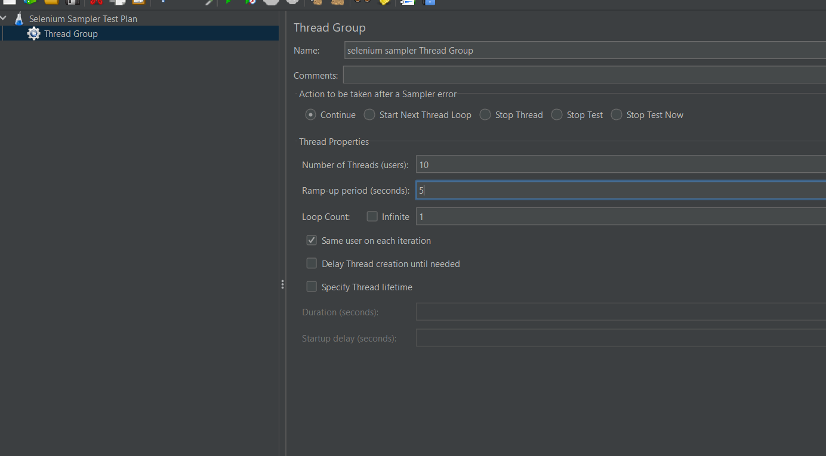

Right click on the selenium sampler Test plan then click on add then click on config Element then select on jp@gc chrome DriverConfig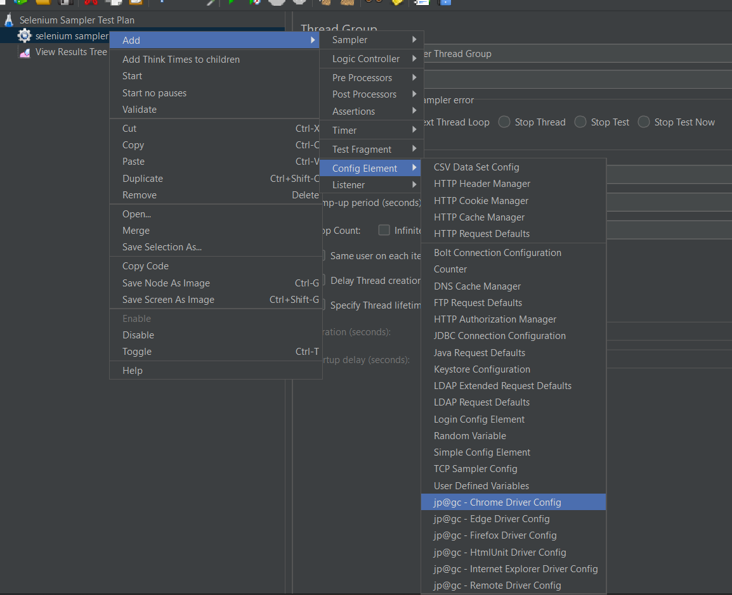

In jp@gc Chrome Driver Config –in path to driver (give the path of chromedriver which is downloaded and give extention as \chromedriver.exe

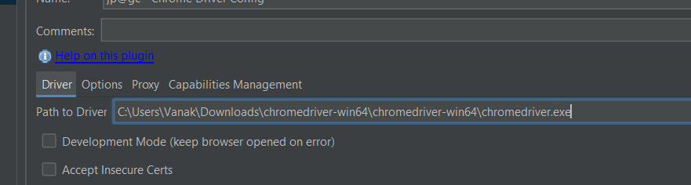

Right click on the selenium sampler test plan then click on add then click on sampler then select jp@gc sampler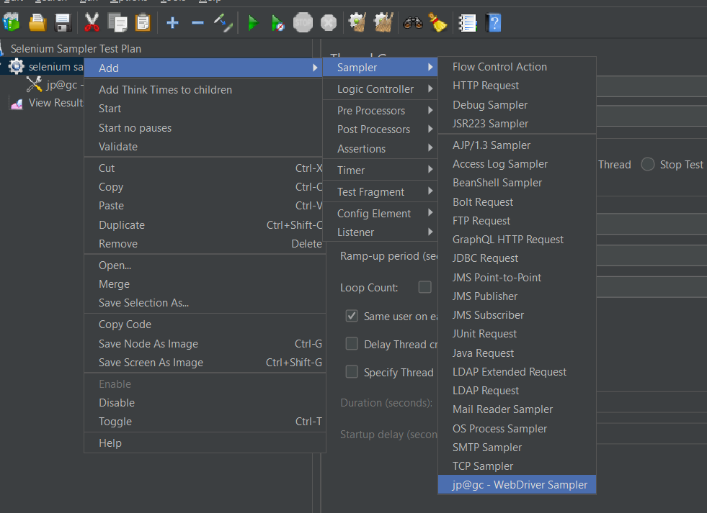

Right click on test plan then click on add then click on listener then click on view Result tree

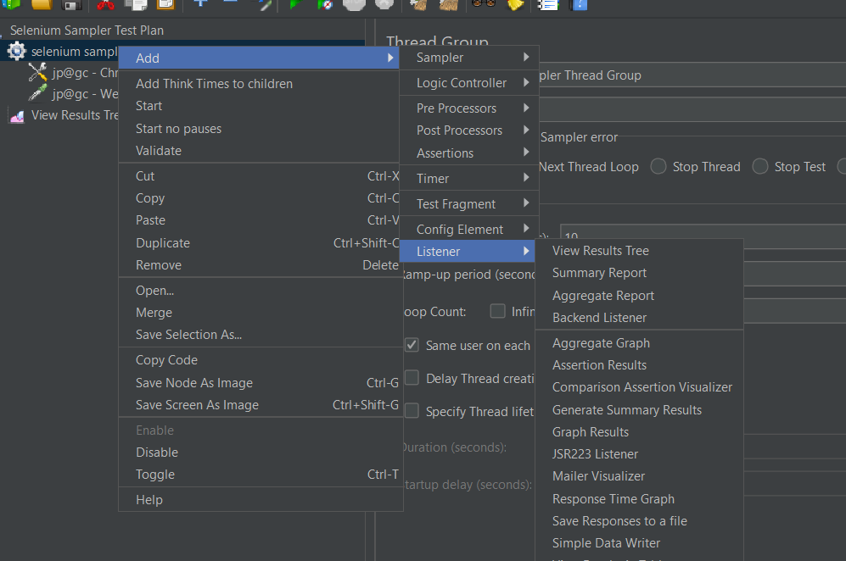

Write the selenium script in script box

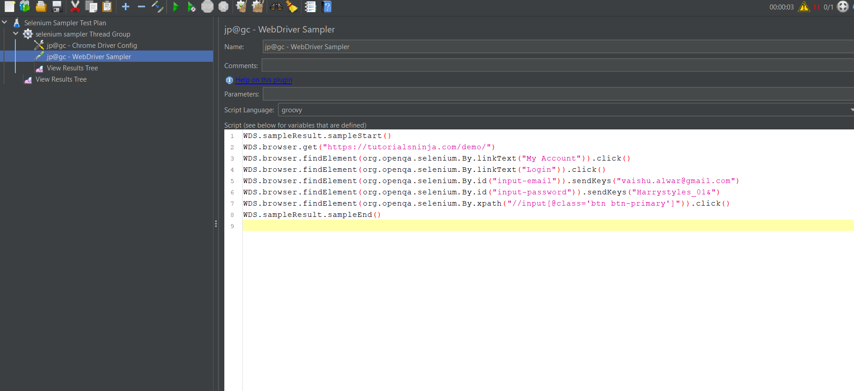

Then click on run button

